
Excellent Coaching Style and Tools!

I didn’t prepare myself for any positive outcome as I have probably related my story millions of times to those that shouldn’t have known about my business. Well, I guess this comes from dealing with pain of domestic abuse and the loss I felt, losing all I have worked for to my Ex. When I was introduced to Dr Grace, I probably didn’t expect anything different from my previous experience.
Dr Grace’s coaching style greatly exceeded my expectations. Her coaching tools and strategies that she shared with me were excellent and easy to apply in my daily life.
Being able to share my hopes and plans for the future created a powerful platform for me to
have new strengths to pursue new hopes for a better life for me and my kids.
I now feel so free, having been able to tackle the most important issues I have always
been afraid of. It was such a powerful moment dealing with my spirituality alongside
my divorce issue. I didn’t want the sessions to end.
Dr Grace is amazing, and I unreservedly give her five stars – 5*****
Ade, London, UK.

Outstanding!

Dr. Anderson is more than a ‘coach.’ She is a professional who listens to you as a friend without judging you, helping you unpack the many burdens of being human. Dr. Anderson uses a wide range of tools to help you grow and find the right balance to achieve your goals. The quality of service she provides is outstanding and definitely gives value for money. I will use this service anytime any day.
Ernestina C.
Texas, USA.
DR GRACE ANDERSON.
https://drgraceanderson.com.
TESTIMONIALS FROM VARIOUS SATISFIED CLIENTS
RE: COACHING SUCCESS – DIVORCE AND BREAKUP RECOVERY.
Very Quick Results!
I was not happy at all in my Marriage. There was no real communication between me an my Ex. He cheated on me many times – I am sure because he was always out, and never told me where he was going etc. To make matters worse, he returned from work one day and told me he was leaving me for another woman.
I cried my eyes out! We eventually got divorced. After the divorce, I found everything really difficult until a friend recommended Dr Grace.
Wow, what a relief – even after just one session! She set up an Action Plan with me. Since working on those actions, things have improved vastly for me. I highly recommend Dr Grace, if you need help getting over your divorce or breakup pain.
Alice, B.
London, UK.

Verity, New Zealand.
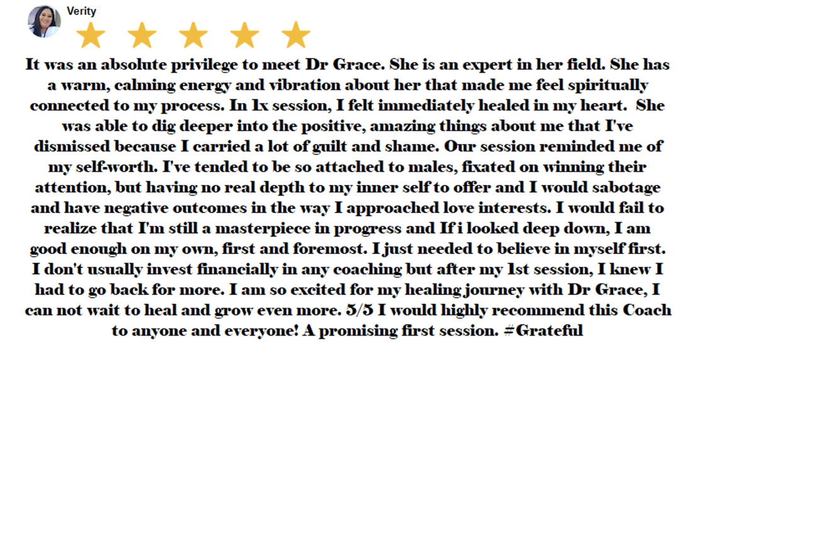
Marsha, UK.
“I first saw Dr Grace’s Profile on Sara Davison’s’ Coaching Hub.
After viewing Dr Grace’s information on YouTube and online, I decided to choose Dr Grace based on her personality, and what I saw as a professional mature person, who knew and understood about the complexities of abusive relationships. And then after speaking with her on a Zoom call, I realised that she too had her own personal stories to tell regarding domestic abuse.
Dr Grace is by far the calmest and most professional McKenzie Friend that I have ever met or come across during this process. She has a very gentle way about her demeanour and instantly makes you feel calm and relaxed at the offset. I have no regrets and would hire her again for her divorce coaching services, as I am very keen to take on her other courses.
I would highly and absolutely recommend Dr Grace’s service, as she has the ability and know how to make you feel calm and relaxed, even during a high-conflict and traumatic situation. I did my research before deciding, and I am so glad that I made the right decision.
I give her 5***** and more!”

Angie, UK.
I had recently separated from my husband, which had come as a total shock, after 37 years, and I had no idea it was coming. I talked through my situation with Dr Grace on my Discovery Call, and how devastated I felt after what had been done to me. Dr Grace listened to me attentively and actively. I could see that she totally empathized with me, but not once did she interrupt me as I poured out my sorrow.
She encouraged to think positively and not see the last 37 years as a waste of time. She said I should focus on the good things that had happened during that time, and the things I had done, places I had been and things that I had, and wouldn’t have happened, if I hadn’t spent the last 37 years with him. I never thought of it that way, so this one strategy of “Counting my Blessings instead of my Losses”, shifted my negative focus massively!

Dr Grace helped me heal quite quickly by highlighting that everything wasn’t my fault, and that I’m not a bad person. She taught me how to turn everything on its head and put a positive slant on everything.
I had Sleep issues, feelings of failure and lost my self-confidence. My Colleagues at work noticed that, and I felt ashamed. In short, I was a mess! But after just my Introductory First Session with Dr Grace, she so calmed me down by her soothing and reassuring words, that for the first time in about 4 months, since that heart-breaking event, I was able to sleep like a baby for more than six hours non-stop that night!
That was incredible!
More than anything else, Dr Grace’s coaching gave me the validation that I wasn’t the only person going through this sort of situation, (although I still think that a sudden decision by my Ex to end a marriage after such a long time with me (37 years) has to be pretty rare)!
I highly recommend Dr Grace’s coaching to anyone who has had a breakup or divorce. I have no words to describe how very effective her coaching is! I give her many stars! Five stars don’t seem to be enough.

Jocelyn, Canada.
Jocelyn said she only contacted me because her younger sister found me online and gave her my details. Our first coaching session was difficult because she was highly emotional and kept saying that she was “stuck” and cried any time she mentioned her abusive Ex who had now left their home and is making the divorce process extremely difficult by his total refusal to cooperate or follow her Solicitor’s instructions.
At the end of our Coaching Journey, here’s her review.
“I am so glad my younger Sister found you for me. You are a Godsend, Dr Grace. You have so clarified my issues, and empowered me with all your excellent coaching tools, that I now feel like a new person! Even my 20-year-old son, who used to get angry with me regularly, since his Dad left us together, is now going with me for my evening walks! We are so happy now that he understands my position, and he has become very supportive of me! Thank you so much for being such a wonderful Coach! I now look forward to a much happier future. I highly value your coaching and I will recommend you to any one in my situation to use your service. Yes, 5 stars is what I give you! Thank you.”

